TESLA, INC.  
CASE STUDY REPORT

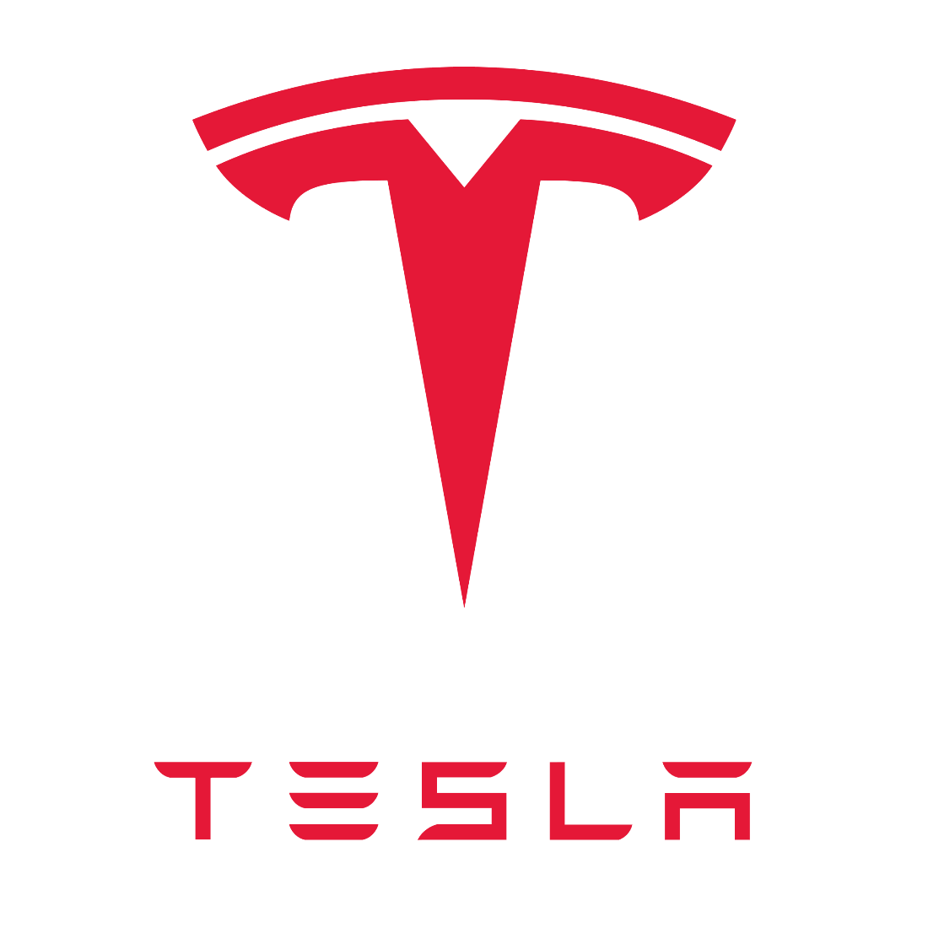

Jason Gardner (n0148000)  
Patrick Nelson (n00158428)  
Joe O’Connor (n00081799)

COP3855 – Web Systems Development  
Richa Jethwani – Fall 2022

**Business Introduction**

“Tesla was founded in 2003 by a group of engineers who wanted to prove that people didn’t need to compromise to drive electric – that electric vehicles can be better, quicker and more fun to drive than gasoline cars. Today, Tesla builds not only all-electric vehicles but also infinitely scalable clean energy generation and storage products. Tesla believes the faster the world stops relying on fossil fuels and moves towards a zero-emission future, the better.” [1]

Tesla Inc, previously Tesla Motorcars, was founded by two engineers, Martin Eberhard and Marc Tarpenning. The company existed on paper, with no real products, until it gained the attention and financial backing of PayPal founder Elon Musk in 2004 as Eberhard and Tarpenning began raising capital. Musk would contribute more than $30 million to the company while they were raising funds to launch their first product, The Tesla Roadster, in 2004 [2]. The Tesla Roadster was a vehicle aimed at the luxury and sports car market starting at a hefty price tag of $98,000 (MSRP) and was Tesla’s first commercial product, in competition with vehicles like the BMW Z4, Porsche Boxter, and Mercedes Benz SLK [3]. Tesla’s Roadster was a success and was released to much acclaim in 2008; receiving rave reviews by automobile enthusiasts. Tesla’s plan was to release a vehicle into the luxury and sports car segments of the market in order to finance the research and development required to bring low-cost, practical electric vehicles to market. That their business exists today is a testament to the success of this strategy [6].

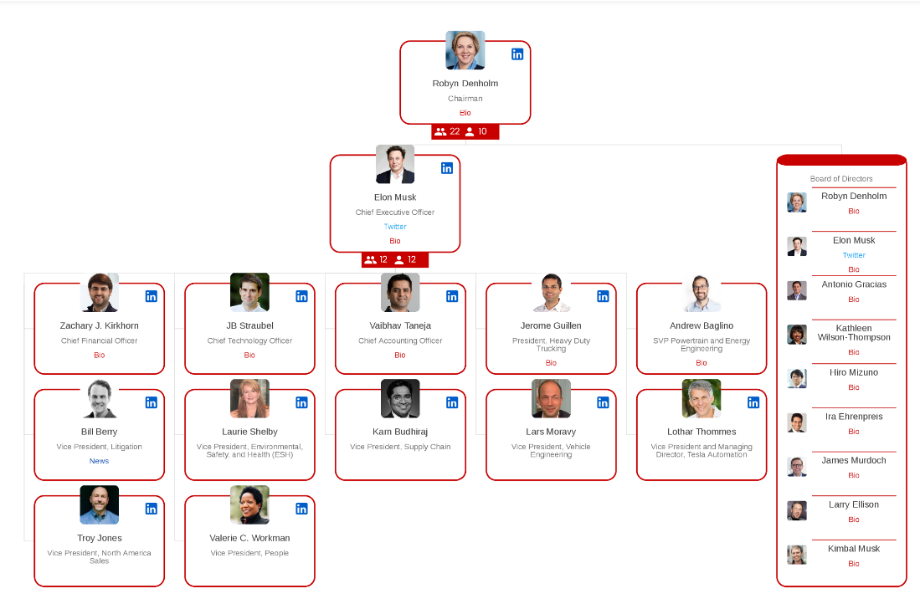  
**Figure 1.1** – *Tesla Corporate Structure*

In 2008, Elon Musk became the CEO of the company after Eberhard resigned and joined the advisory board, followed by Tarpenning. In 2010 Tesla’s IPO raised $226 million [2]. Musk remains the CEO of Tesla, Inc and has overseen the company’s successful rise to be a brand that is synonymous with electric cars. The company has been so successful in this regard that they have reported no spending on advertising in recent years and have reached a market capitalization of over $1 trillion and are one of only a handful of companies to reach such a high valuation [4].

Tesla, Inc. is primarily a Business to Consumer (B2C) business and is exceptionally vertically integrated for a company in the automotive segment. Tesla sells automobiles directly to customers. A traditional car manufacturer competes with other manufacturers but must also respond to supply-side concerns. Tesla has built out their business in such a way that they were able to meet production goals during the pandemic when traditional automobile manufacturers were experiencing severe supply chain issues. In particular, the semiconductor shortage at the height of the COVID pandemic was particularly devastating to automobile manufacturing. Tesla's success has inspired their competitors to try to play catch up and change the ways they do business [5].

Tesla sells their automobiles almost entirely online, directly to consumers. In places in the United States where this type of sale direct to consumers is illegal and some sort of dealership is necessary, they maintain business facades with a minimal number of vehicles available on the floor for sale and test drives. The location and employees staffing the location are primarily there to assist customers in buying their vehicles online. This loophole in United States law has allowed Tesla to bypass the laws designed so that car dealerships can markup vehicles one final time before they arrive in the hands of consumers and has added another competitive advantage for Tesla in automobile sales [20].

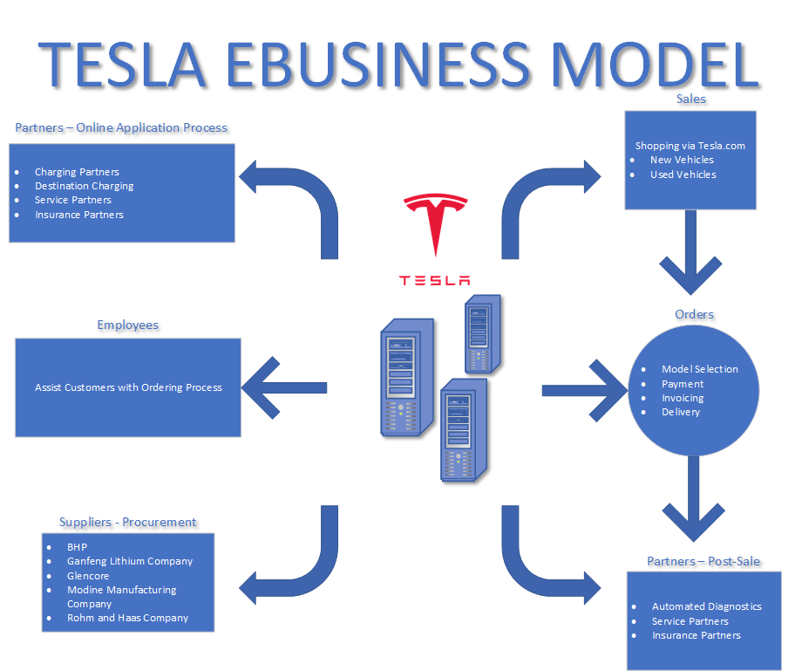  
**Figure 1.2** – *Tesla eBusiness Model*

Tesla maintains partnerships with the business and service partners using eBusiness processes. Procurement of materials for the manufacture of Tesla’s vehicles is handled through electronic communication as part of a global supply chain. Tesla’s high levels of vertical integration minimize the use of outside suppliers as much as possible. Customers interact with Tesla through their web site at [https://tesla.com](https://tesla.com/) and through a mobile application, and support from Tesla employees is available at all stages of the process. Customers can customize and order their vehicles through the web site, where that order is processed and queued for manufacture at a Tesla factory. Customers can track the progress of their order online. After customers have their vehicle, the mobile application allows customers to interact with their vehicle(s) and schedule service for the few components, like tires, that experience wear over the life of a vehicle. Tesla vehicles can receive over-the-air software updates and provide technicians with detailed diagnostic data from anywhere in the world, where Tesla or a certified technician can diagnose issues with their car. After reporting came out that Tesla vehicles had a high repair cost, Tesla began providing their own insurance product where they were able and partnered with insurers to make sure that customers were able to acquire affordable insurance for their vehicles. Tesla has an online application process for charging partners to apply to host full charging stations or “destination charging” wall plugs.

Tesla was built from the ground up as an eBusiness, and competitors are taking their time catching up. Potential competitors have seen how successfully Tesla has streamlined the processes around manufacturing, selling, and maintaining electric vehicles. While Tesla might have direct competitors in the future, they currently account for 68% of all electric vehicle sales in the United States [17]. California has announced that the state intends to have all vehicles sold in the state be electric by the year 2035 [18]. Tesla has potential competition from every existing vehicle manufacturer, but the company managed to carve out a niche in the market that ensured that they maintain their “first mover advantage” for the immediate future.

Tesla appears to have gained substantial advantage from building their business as an eBusiness, first and foremost. The company and the customers both benefit from some of these advantages. Costs are minimized for Tesla and customers can buy vehicles that have passed through the smallest number of markups. Tesla has managed to work around potential inhibitors, like United States laws designed to bilk consumers out of additional money by artificially creating an entire class of predatory intermediaries in a supposedly free market economy. As the proverbial first mover, they have been forced to bear the burden of paving the way for technologies, like self-driving. Nearly every accident involving one of their vehicles makes news. These are inhibitors to their business they need to overcome. There are conveniences to Tesla and their customers realized through their streamlined ordering process, online service and management of their products, and partnerships that have allowed them to build out a national charging network to support their vehicles where none existed when their first vehicle was sold.

Tesla’s plan to sell high-end vehicles to fund the research and development necessary to sell vehicles for everyday drivers has been an unqualified success for them. Their most popular model, the Model 3, is priced at a base price of $46,990, and is slightly less expensive than the average of $48,182 for a new vehicle in July 2022 [16]. Their market share is a testament to the success of Tesla as an automotive manufacturer. Even as more competitors come from behind to try to mimic Tesla’s vertical integration and sales strategies, there is no denying Tesla is a success story in the automotive industry. Tesla manufactures and sells automobiles, provides access to first- and third-party maintenance for their vehicles, maintains charging infrastructure for electric vehicles and sells electricity, licenses their technology to other manufacturers to accelerate the pace of electric vehicle adoption, and provides access to insurance products for their vehicles.

**e-Business Strategy**

Tesla’s e-business and growth strategy involves all sales going only through its online portal, expanding its enterprise systems capabilities, transforming the physical retail experience, and further developing and optimizing Tesla’s resource planning software. [21]

By having all its business and sales conducted through its online platform Tesla can cut out the middleman, save significantly on costs, and reach a wider audience of potential future customers. [21]

To expand its retail experience Tesla continues to develop “Tesla Centers” that act as showrooms, delivery centers, and sometimes are also combined with service centers. During the Tesla vehicle purchasing process, a customer is assigned a “Tesla Advisor” at their closest center to help them during the process and delivery. [21]

In 2012, Tesla began building its e-commerce and resource management software system (ERP), which has since become integral to the entire Tesla enterprise. It integrates nearly every resource and steps needed for the company to operate into a single system and covers, among other things, human resources, sales, inventory, purchasing, finance, marketing, planning, and many other areas and sub-categories. [21]

Tesla’s ERP system distinguishes itself from other packages due to its fully integrated, seamless nature, flexibility, and scalability. This system allows Tesla to operate in the way that the wider world has come to know it as.[21]

**Business Model**

Tesla’s business model is the Manufacturing Direct Model, or basically a direct-to-the-consumer model, forgoing any middlemen. Tesla produces electric vehicles and renewable energy-related products and then sells them directly to consumers via its online storefront. [1]

In addition, Tesla operates physical fronts that serve as a customer showcase for Tesla’s electric vehicles. Even when physically in the store, all Tesla vehicle sales must still go through Tesla’s online platform, which includes further products.

Tesla also offers its own charging network. [1]

Between 80%-90% of Tesla’s revenue stream comes from sales of electric cars. It reports sales for each quarter, as well as annually, and its revenue for the Q2 of 2022 was 16.9 billion, a 42% YoY increase. [1]

Tesla’s vehicle offering includes mid-price range cars but also high-end cars and a sport edition.

Greener solutions are part of Tesla’s value proposition, and they strive to include long-range and efficiency in their electric vehicle products. [1]

On the renewable energy side of things, Tesla offers home batteries and solar panels to its customers.

Tesla also offers loans, insurance, and leases as additional revenue streams.

**Future Projections**

Tesla plans to grow its manufacturing capacity and achieve 50% growth in vehicle deliveries each year for several years. This rate of growth is dependent on equipment capacity, factory uptime, operational efficiency, and the capacity and stability of the supply chain. [1]

Tesla further plans to accelerate growth in software-related projects. [1]

Further product and technology expansions are planned and in development. An example is the industrialization of the Cybertruck. [1]

Relationship Management

**Consumers**

To understand Tesla's relationship management with consumers, it is important to look at their mission statement which is:

"To accelerate the advent of sustainable transport by bringing compelling mass market electric cars to market as soon as possible" [6].

Tesla customers can be categorized as climate conscious, tech savvy buyers. They gain customer loyalty by constantly staying in the news regarding their electric vehicle's positive effects on the environment and developing and marketing very high-end technology for their vehicles such as Autopilot and Full Self Driving vehicles [16]. The figure below displays Tesla's expenditures on advertising shown in red and research and development (R&D) shown in orange [7].

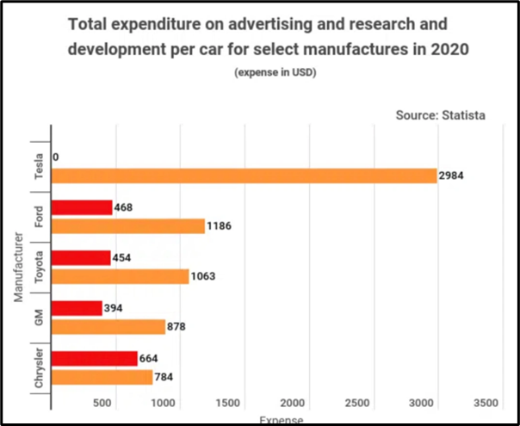  
**Figure** – *Total Expenditure on Advertising and R&D per Car by Manufacturer*

While they do not advertise directly, they are experts at developing brand loyalty due to their commitment to clean energy and their technical lead in state-of-the-art Battery Electric Vehicles which results from their high expenditures on R&D. They consistently attract new buyers by word-of-mouth advertising, marketing materials on their website specific to their vehicle's technology, and how their vehicles promote sustainable energy. Auto sales are over 80% of their revenues and as such, they have developed advanced technology on their vehicles to improve their relationship with customers [13]. They consistently attract new buyers by word-of-mouth advertising, marketing materials on their website specific to their vehicle's technology, and how their vehicles promote sustainable energy. They have developed numerous features to improve their relationship with customers. Among these promised values are:

* Owning their own sales sites for test drives and deliveries. This allows them to control how they market their products and reduce customer friction due to sales tactics not approved by Tesla.
* Providing one non-negotiable price. This reduces customer friction since they do not have to try to negotiate a price. They simply select their vehicle and options from the web site and the price is fixed.
* Providing a simple test drive experience. They even have sites at malls where a customer can simply show their driver's license and then get directions to where the test car is in the mall parking lot.
* Provide an exceedingly easy sales experience. As will be described in the following section, all purchases are through their E-Commerce web site which Tesla has made exceedingly simple.
* Benefit from strong word of mouth marketing. Tesla markets their product to very environmentally conscious customers. As such these customers are very energetic about recommending their vehicles. Tesla provides detailed data on how their vehicle will reduce carbon emissions which is at the forefront of their mission statement.
* Focusing on developing advanced technology. As stated above, Tesla dwarfs the other automobile companies in Research and Development [7]. This allows them to be at the forefront of technologies such as Autopilot, Full Self Driving Vehicles, and enhanced safety features. All of which are highly desirable by their customers even though only the latter is included at no cost.

**Suppliers**

Many Tesla suppliers are typical of a large automobile manufacturer. They source auto parts, steel, electrical parts, and other parts typical for an automaker.

Tesla does not provide information regarding its suppliers; however, they do have their own web site dedicated to them. Below are some purported key suppliers for Tesla's manufacturing production. These are shown in the Tesla impact statement required by the government because of the mining they require [9].

|  |  |
| --- | --- |
| Supplier | Material |
| BHP | Nickel |
| Gangfeng Lithium Company | Lithium |
| Glencore | Cobalt |
| Modine Manufacturing Company | Battery Chiller |
| Rohm and Haas Company | Specialty Materials |
| Panasonic | Batteries |

A special mention should be made regarding the batteries for their vehicles. In 2021 Tesla entered into an agreement with Panasonic to support the production of battery manufacturing in Tesla’s Gigafactory.

This agreement has resulted in Tesla being heavily reliant on Panasonic for much of its battery manufacturing and car batteries with Tesla currently trying to reduce this dependence.

In late 2020 CEO Elon Musk outlined a strategy to develop their own batteries which have 5 times the existing storage. This would allow them to cut the current vehicles prices significantly. However, as of this date they have not achieved the scale they need to power most of their vehicles and are still reliant on other vendors for portions of their need [11].

**Business Process Models**

This section describes the Tesla E-Business model in terms of its support for their automobile sales. In 2022 this accounts for over 80% of their sales revenue and that revenue is 100% supported by their E-Business strategy of selling all vehicles online [13]. The Tesla E-Commerce model is identical for all 4 models, Model 3, Model Y, Model X, and Model S. Those are shown on their main E-Business web page in ascending base price from $48,400 to $122,400 by scrolling down the introductory page. However, there is no difference in the E-Business model for buying any of them as one can see by following their main E-Commerce page to purchase one of the 4 vehicles.[14].

The introductory web page for purchasing their vehicles has a splash screen depicting the Model 3. Paging down brings up the Model Y, then Model X and then Model S. On any screen there are two choices, custom order, and existing inventory. The choices bring up the following

**Business Model for New Custom Order**

The summary below is for their entry level Model 3 sedan. The process shown is identical for the other three models with the exception that there are a few additional options available on them.

The main screen shows a picture of the car with two selection options for purchase, custom order or existing inventory. If a custom order is selected, an entry screen is shown with the price, performance characteristics and estimated delivery date. Then on the same page the customer selects:

* An optional Dual Motor all-wheel drive with performance wheels
* A selection of 2 standard colors or other 3 additional priced colors
* A choice of standard 19-inch tires or optional 20-inch tires if Dual Motor is not selected
* A choice of Interior color, black or additional priced white/black seats
* An option for Enhanced Autopilot
* An option for Full Self-Driving (FSD) Capability
* Optional Charging Accessories
  + Wall connector
  + Mobile connector

*Note: The Model Y, X, and S come standard with dual motors. The Model X and S both have optional triple motors.*

Once the above selections have been made the customer selects a continue to payment screen which brings up a screen showing:

* Vehicle Options Selected
* Type of Payment
  + Cash
  + Lease
  + Loan.
* Pricing, Vehicle Price, destination charge, and ordering fee ($250).

The customer then selects the order with a card which brings up additional data collected:

* Select Type of Purchase
  + Cash
  + Lease
  + Loan
* Deposit Required
* Name
* Email Address
* Phone
* At that point the customer selects “Order with Card” where the customer enters
  + First Name
  + Last Name
  + Email Address
  + Confirmed Email Address
  + Phone Number
  + Name on Card
  + Card Number
  + Expiration Month
  + Expiration Year
  + CCV Number of Card
  + Billing Zip Code

Once that information is provided the customer selects the order button. After the order is placed, the customer logs into their web account to track the delivery date, and other details.

**Model for Existing Inventory (New and Used)**

This option brings you to a screen where the customers zip code is entered. Selections allow the choice of all 4 models for:

* Search Radius from 25 to 200 Miles.
* New or Used Vehicles.
* Options Desired.

Using these criteria any available models are shown with:

* Odometer Reading
* VIN (Vehicle Identification Number)
* Price
* Delivery Fee

Choosing one of these vehicles bring up a screen showing:

* Vehicle VIN
* Vehicle Condition
* Vehicle Options
* Warranty
* Delivery Destination Choice
* Choice to Include Charging Accessories

The customer then chooses to continue to payment where the price and deposit fee is shown along with a button to order with a credit card. That option takes the customer to a screen which records the credit card information. That screen prompts for:

* + First Name
  + Last Name
  + Email Address
  + Confirmed Email Address
  + Phone Number
  + Name on Card
  + Card Number
  + Expiration Month
  + Expiration Year
  + CCV Number of Card
  + Billing Zip Code

After the order is placed, the customer logs into their web account to track the delivery date.

**Web Systems Evaluation**

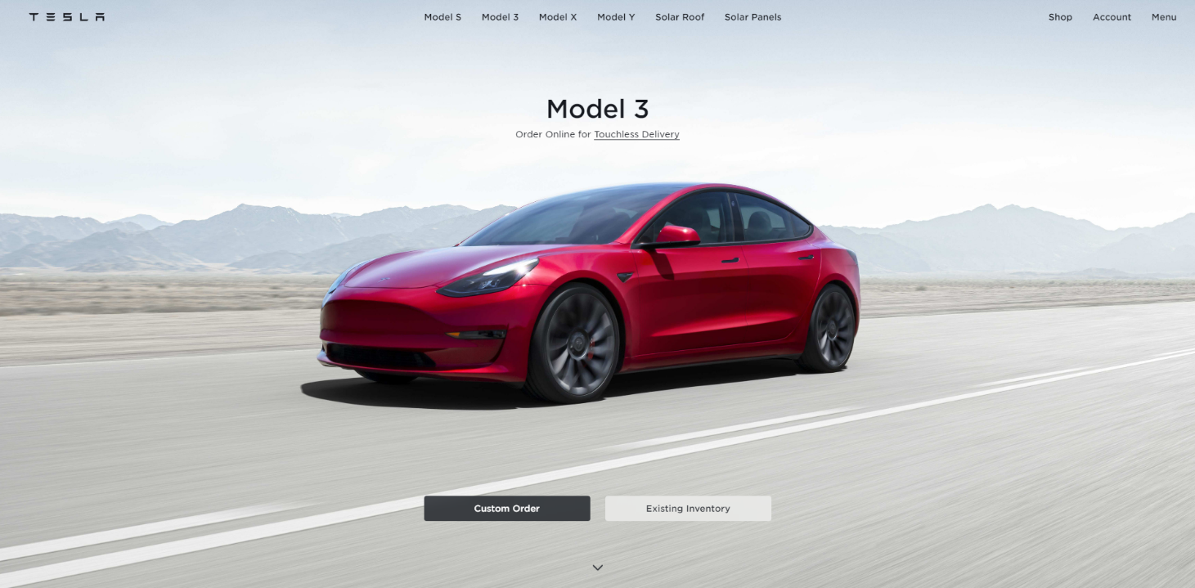**Figure 2.1** – *Tesla Landing Page*

Tesla’s web site, [https://tesla.com](https://tesla.com/) [Fig. 2.1], is well designed for both mobile and desktop use by existing and potential customers and is appealing for the target demographic of people who want to buy a technologically advanced electric vehicle. Immediately upon arrival at the site, potential customers are provided links to the process to begin their order for a Model 3, Tesla’s most popular model of vehicle. The focus on ease-of-use continues as the customer scrolls down the page and is provided with the opportunity to start their order for any of the company’s products or learn more about them.

Choosing a specific vehicle on the menu bar on top of the page brings the user to a series of informational pages that are scrolled horizontally, like the main page, showing information about the chosen vehicle [Fig. 2.2]. These slideshows are breakdowns of the selling points of specific vehicles, emphasizing specific features. Each slide has a picture or video and text description of features specific to the vehicle and contains all the information one would expect to see in advertising if Tesla advertised their vehicles. These pages include a link to the User Manual for the choice of vehicle.

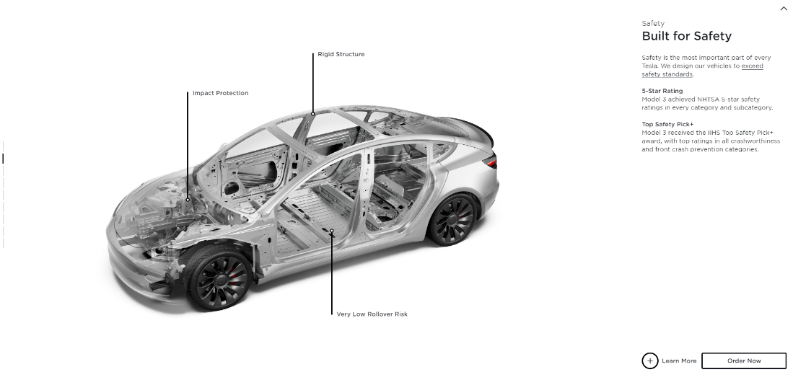  
**Figure 2.2** – *Specific Vehicle Information Slideshow*

  
**Figure 2.3** – *Mobile Navigation Menu*

There is a navigation bar on top of the site that is condensed to a menu button on mobile devices that links to information about a specific product and provides the same easy access to begin a customer’s order once any of the vehicles are chosen [Fig. 2.3]. This menu displays down the right side of a user’s device and allows them to access the page about a specific product, formatted for mobile devices. These information pages display the same information as the slides displayed for desktop devices [Fig. 2.2] but are formatted for mobile devices [Fig. 2.4].

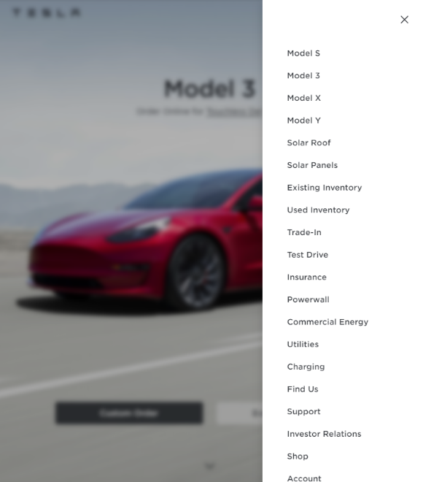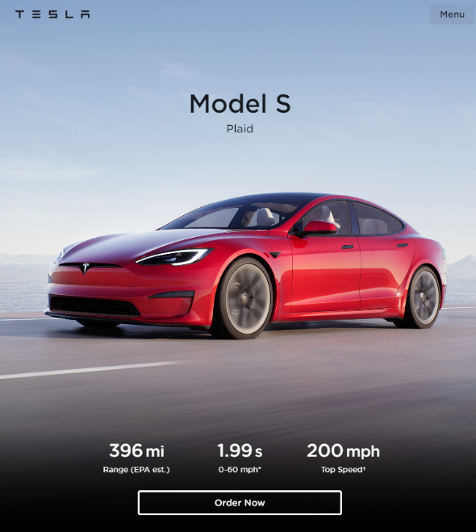  
**Figure 2.4** – *Mobile Navigation Expanded & Mobile Vehicle Information*

The site is compatible with all modern browsers and works on mobile devices of varying screen sizes, adjusting and maintaining a clean navigation feel across devices. The home page uses the vehicles available as the backgrounds as the user scrolls down the page. The transitions between models are smooth, with no fancy effects. The model's name and order buttons for the pictured model show up as the user scrolls to the photograph of that product. The order pages are bright, with a high contrast between the white background and black text, the images include alt text for accessibility, and item descriptions are verbose for users utilizing a screen reader to navigate the site. Tesla’s “Careers” page includes a link to a compatible screen reader and a step-by-step tutorial to help users install the software. Users have access to a “Question Center” popup in the lower right corner to send questions to live chat and have them answered during their purchase process to make it as convenient as possible [Fig. 2.5].

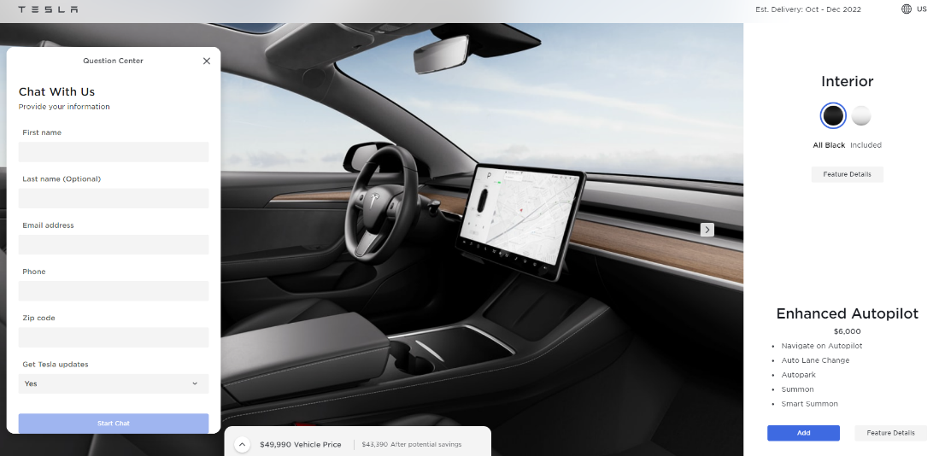  
**Figure 2.5** – *Access to Live Chat*

Vehicle customization options display on the right side of the screen and as the user scrolls down and chooses them, the vehicle that is displayed on the left side of the screen changes to match the chosen options, where they change the appearance of the vehicle. The price is also updated while the user is shopping for options. The data about vehicle customization is stored in cookies stored in the user’s browser, and if the user leaves the vehicle customization and comes back later, their previous customization options remain [Fig. 2.6].

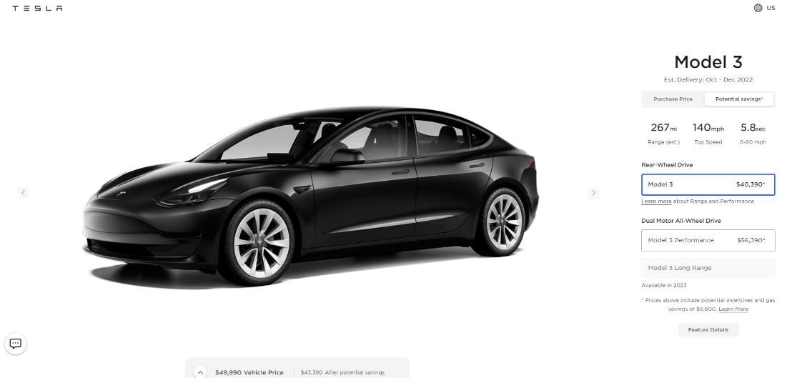  
**Figure 2.6** – *Vehicle Customization*

The options for ordering and links for any specific information about features, such as “Range and Performance” pop up in informational cards and do not direct the user to another page, with clear buttons to exit out of them and return to the original task in the background. Users can access all the informational pages linked from the vehicle page by swiping from left to right through these cards [Fig. 2.7].

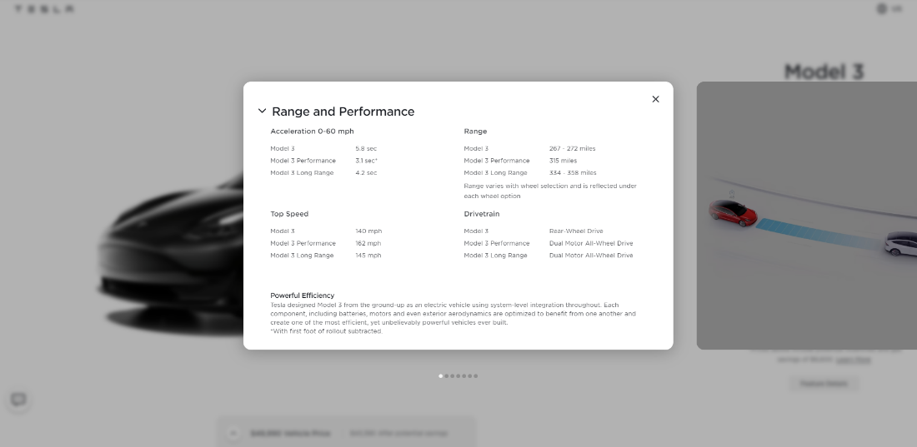  
**Figure 2.7** – *Informational Cards*

Last, but not least, all the pages on Tesla’s website have a footer with links to their “Tesla © 2022,” Privacy & Legal, Vehicle Recalls, Contact, Careers, News, Engage, and Locations pages [Fig. 2.8].

  
**Figure 2.8** – *Page Footer*

|  |  |
| --- | --- |
| Footer Pages | |
| Link | **Description** |
| Tesla © 2022 | Tesla’s history and the company’s plans for the future. |
| Privacy & Legal | * Links to legal documents describing agreements between the customers and Tesla. * Links to the company’s repositories on GitHub containing open-source code. * In privacy, it is worth noting that Tesla’s website only has a single tracking API, through Google. Ford’s website, by contrast and as one of Tesla’s competitors, has sixteen trackers embedded in their web page [17]. |
| Vehicle Recalls | A search interface allows Tesla owners to search for vehicle recalls using their vehicle identification number (VIN). |
| Contact Us | Contact information for inquiries in Sales, Customer Support and Roadside Assistance, Careers, First Responders, Press, and a web form for the submission of questions and comments, followed by locations and links to directions to any of their worldwide offices. |
| Careers | A search interface allowing job seekers to search for keywords and multiple links to “View Jobs” or “View Internships.” |
| News | Tesla’s Blog, Videos, Press Assets, Customer Stories, Events, and a signup form for Tesla’s email mailing list. |
| Engage | Pages for Tesla owners to engage with campaigns of interest to them, such as electric vehicle legislation or energy company policy, along with the ability to connect with other Tesla owners in “Tesla Owners Clubs.” |
| Locations | Access to Tesla Store and Gallery locations and addresses by country. |

Tesla’s website is extremely well designed, containing all the information users could possibly want to consider while buying a vehicle, with the expected accessibility features expected from a modern website. There are minimal barriers between a user arriving to purchase a vehicle and being able to make their purchase. This appears to be a deliberate design decision on Tesla’s part and the site feels very streamlined and without any extraneous or distracting frills.

**Suggestions to Improve Tesla, Inc.**

Going into the future, Tesla should do whatever is possible to maintain the existing advantages they have in the electric vehicle market. They should want their name to remain almost synonymous with electric vehicles in the future. As alternatives do arrive from competitors, Tesla will bear less of the burden of pushing forward adoption of features, like self-driving. Following through with their plans to increase production is an excellent way to ensure that they remain competitive as other companies catch up and begin to release vehicles that are targeting the average consumer instead of their prior strategy of designing uninspired vehicles aimed at a segment of consumers that was perceived as irrationally concerned with the environment. Tesla’s vehicles made doing something good for the environment a standard feature in their vehicles.

Tesla should take advantage of nationalist sentiment in the United States by building more factories in the country to generate positive sentiment with the citizens that object to change on principle. Self-driving will need to clear regulatory hurdles at all levels of government. Pandering to their feigned patriotism will pay dividends and allow Tesla to make their priorities appear to be aligned with the priorities of the citizens. Tesla has focused on self-driving as the next step in the evolution of consumer passenger vehicles, and it is an area where one can expect they will be able to stay ahead of the competition if regulations allow the technology to roll out fully in the near future.

Moving forward with projects like the Cybertruck and continuing to explore the potential of electric vehicles in areas like shipping and logistics could allow Tesla to expand and stay ahead of the competition for the foreseeable future. If Tesla’s history is any example of what to expect from them, it is reasonable that they will choose not to rest on their laurels and simply accept a market share that will dwindle as their competitors close the gap. The rest of the country will follow California in the shift to electric vehicles. Electric vehicles are the future. Should Tesla want to remain relevant in coming years, it will be through continuing to maintain their leads in manufacturing and bringing new, well-priced, technologically advanced transportation to market.

# Works Cited

|  |  |
| --- | --- |
| [1] | Tesla Inc., "Tesla," Tesla, [Online]. Available: <https://www.tesla.com/>. [Accessed 3 September 2022]. |
| [2] | E. Gregersen and B. A. Schreiber, "Tesla, Inc.," Encyclopedia Britannica, 1 September 2021. [Online]. Available: <https://www.britannica.com/topic/Tesla-Motors>. [Accessed 29 August 2020]. |
| [3] | "2008 Tesla Roadster Buyer's Guide: Reviews, Specs, Comparisons," MotorTrend, [Online]. Available: <https://www.motortrend.com/cars/tesla/roadster/2008/>. [Accessed 3 September 2020]. |
| [4] | Tesla Inc., "SEC Filings," Tesla Investor Relations, [Online]. Available: <https://ir.tesla.com/sec-filings>. [Accessed 3 September 2022]. |
| [5] | H. Jin, "Explainer: How Tesla weathered global supply chain issues that knocked rivals," Reuters, 4 January 2022. [Online]. Available: <https://www.reuters.com/markets/europe/how-tesla-weathered-global-supply-chain-issues-that-knocked-rivals-2022-01-04/>. [Accessed 3 September 2022]. |
| [6] | E. Musk, "The Mission of Tesla," Tesla | Electric Cars, Solar & Clean Energy, 24 May 2018. [Online]. Available: <https://www.tesla.com/blog/mission-tesla>. [Accessed 3 September 2022]. |
| [7] | F. Lambert, "Tesla spends the most R&D and least in advertising per car sold," Electrek, 24 March 2022. [Online]. Available: <https://electrek.co/2022/03/24/tesla-spends-most-rd-least-advertising-car-sold/> . [Accessed 3 September 2022]. |
| [8] | F. Rojas, "Council Post: Eight Digital Marketing Lessons We Can Learn From Tesla," Fobes, 14 April 2022. [Online]. Available: <https://www.forbes.com/sites/forbesagencycouncil/2020/12/10/eight-digital-marketing-lessons-we-can-learn-from-tesla/>. [Accessed 3 September 2022]. |
| [9] | Tesla, Inc., "Impact Report 2021," 2021. [Online]. Available: <https://www.tesla.com/ns_videos/2021-tesla-impact-report.pdf>. [Accessed 3 September 2022]. |
| [10] | J. B. Maverick, G. Scott and M. Kazel, "Who Are Tesla's Main Suppliers?," Investopedia, 29 June 2022. [Online]. Available: <https://www.investopedia.com/ask/answers/052815/who-are-teslas-tsla-main-suppliers.asp>. [Accessed 3 September 2022]. |
| [11] | H. Jin, "Musk's plan for Tesla-built batteries has an acceleration challenge," Reuters, 22 March 2022. [Online]. Available: <https://www.reuters.com/business/autos-transportation/musks-plan-tesla-built-batteries-has-an-acceleration-challenge-2022-03-11/>. [Accessed 3 September 2022]. |
| [12] | The Tesla Team, "Update on Tesla Stores and Pricing," Tesla | Electric Cars, Solar & Clean Energy, 11 March 2019. [Online]. Available: <https://www.tesla.com/blog/update-tesla-stores-and-pricing> . [Accessed 3 September 2022]. |
| [13] | G. Cuofano, "Tesla Business Model Analysis 2022," FourWeekMBA, 18 May 2022. [Online]. Available: <https://fourweekmba.com/tesla-business-model/> . [Accessed 3 September 2022]. |
| [14] | Tesla Inc., "Electric Cars, Solar & Clean Energy," Tesla, [Online]. Available: <https://www.tesla.com/>. [Accessed 1 September 2022]. |
| [15] | Tesla Inc., "Autopilot and Full Self-Driving Capability," Tesla, 22 August 2022. [Online]. Available: <https://www.tesla.com/support/autopilot>. [Accessed 31 August 2022]. |
| [16] | Cox Automotive Inc., "New-Vehicle Prices Set New Record in July 2022, According to Kelley Blue Book, as Inventory Improves Year-Over-Year and Luxury Share Remains Elevated," 10 August 2022. [Online]. Available: <https://www.coxautoinc.com/market-insights/kbb-atp-july-2022/>. [Accessed 5 September 2022]. |
| [17] | Ford Motor Company, "Ford® - New Hybrid & Electric Vehicles, SUVs, Crossovers, Trucks, Vans & Cars," [Online]. Available: <https://www.ford.com/>. [Accessed 5 September 2022]. |
| [18] | F. Lambert, "Tesla (TSLA) still dominates US electric car market with 68% market share," Electrek, 15 August 2022. [Online]. Available: <https://electrek.co/2022/08/15/tesla-tsla-dominates-us-electric-car-market-share/>. [Accessed 5 September 2022]. |
| [19] | "Governor Newsom Announces California Will Phase Out Gasoline-Powered Cars & Drastically Reduce Demand for Fossil Fuel in California's Fight Against Climate Change," California Governor, 26 April 2021. [Online]. Available: <https://www.gov.ca.gov/2020/09/23/governor-newsom-announces-california-will-phase-out-gasoline-powered-cars-drastically-reduce-demand-for-fossil-fuel-in-californias-fight-against-climate-change/>. [Accessed 5 September 2022]. |
| [20] | P. Stenquist, "Why You Might Buy Your Next Car Online," The New York Times, 21 June 2022. [Online]. Available: <https://www.nytimes.com/2022/06/21/business/tesla-online-sales-dealerships.html>. [Accessed 5 September 2022]. |
| [21] | Wong, Patrick, “Tesla’s Digital Strategy for Becoming A Trillion Dollar Company,” Fabric.inc, April 2022. [Online]. URI: <https://fabric.inc/blog/tesla-strategy/>. [5 September 2022] |

**Team Member Sections**

|  |  |
| --- | --- |
| **Team Member** | **Sections** |
| Jason Gardner (n0148000) | Title Page  Business Description  Web Systems Evaluation  Improvement Suggestions  Works Cited |
| Patrick Nelson (n00158428) | Business Model |
| Joe O’Connor (n00081799) | Relationship Management  Business Process Models |